Q2. Manual BPE on a toy corpus
2.1 Using the same corpus from class:
low low low low low lowest lowest newer newer newer newer newer newer wider wider wider new new
- Add the end-of-word marker _ and write the initial vocabulary (characters + _).
- Compute bigram counts and perform the first three merges by hand:
  - Step 1: most frequent pair → merge → updated corpus snippet (show at least 2 lines).
  - Step 2: repeat.
  - Step 3: repeat.
- After each merge, list the new token and the updated vocabulary

2.2 — Code a mini-BPE learner
- Use the classroom code above (or your own) to learn BPE merges for the toy corpus.
  - Print the top pair at each step and the evolving vocabulary size.
Code:
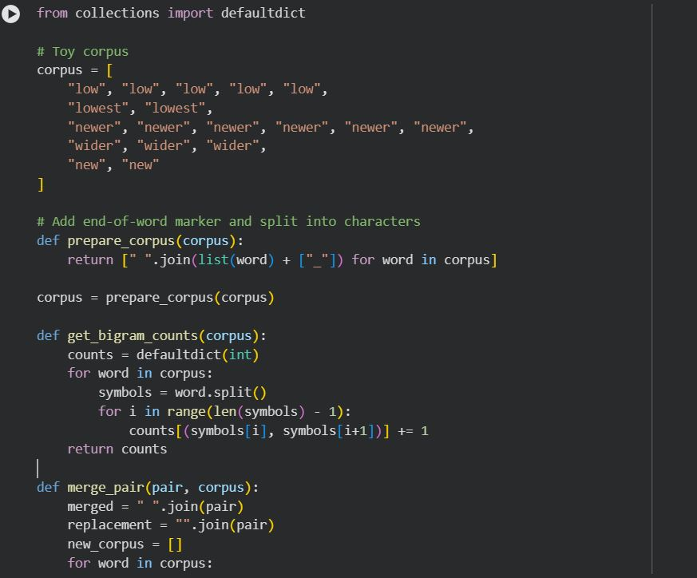
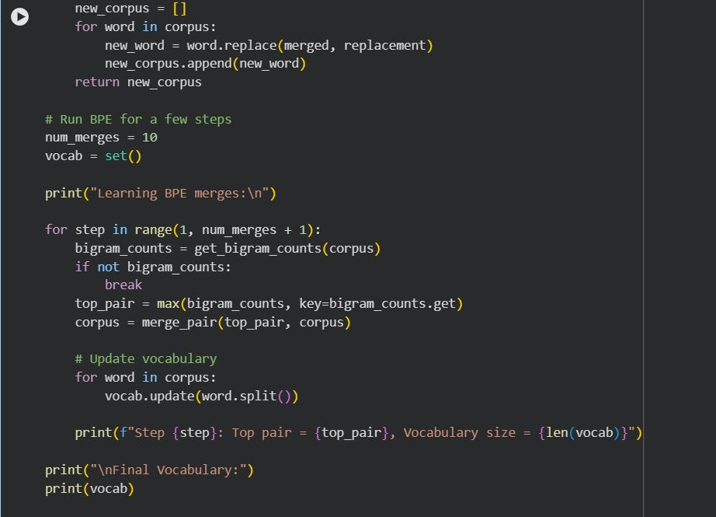
Output:
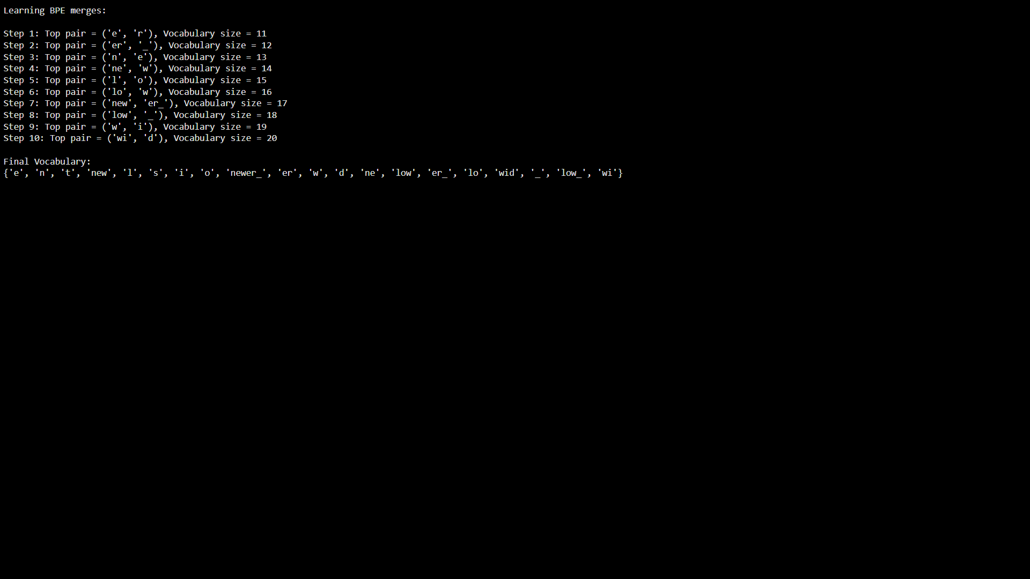
- Segment the words: new, newer, lowest, widest, and one word you invent (e.g., newestest).
  - Include the subword sequence produced (tokens with _ where applicable).
Code:
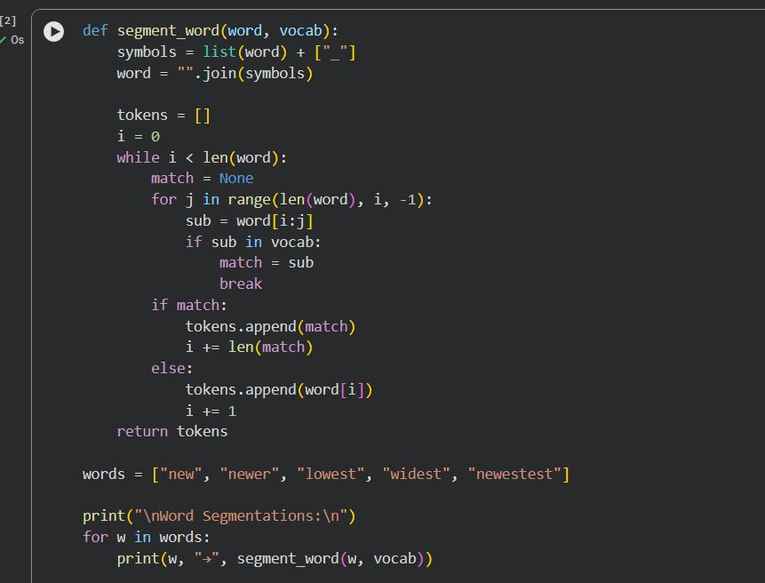
Output:
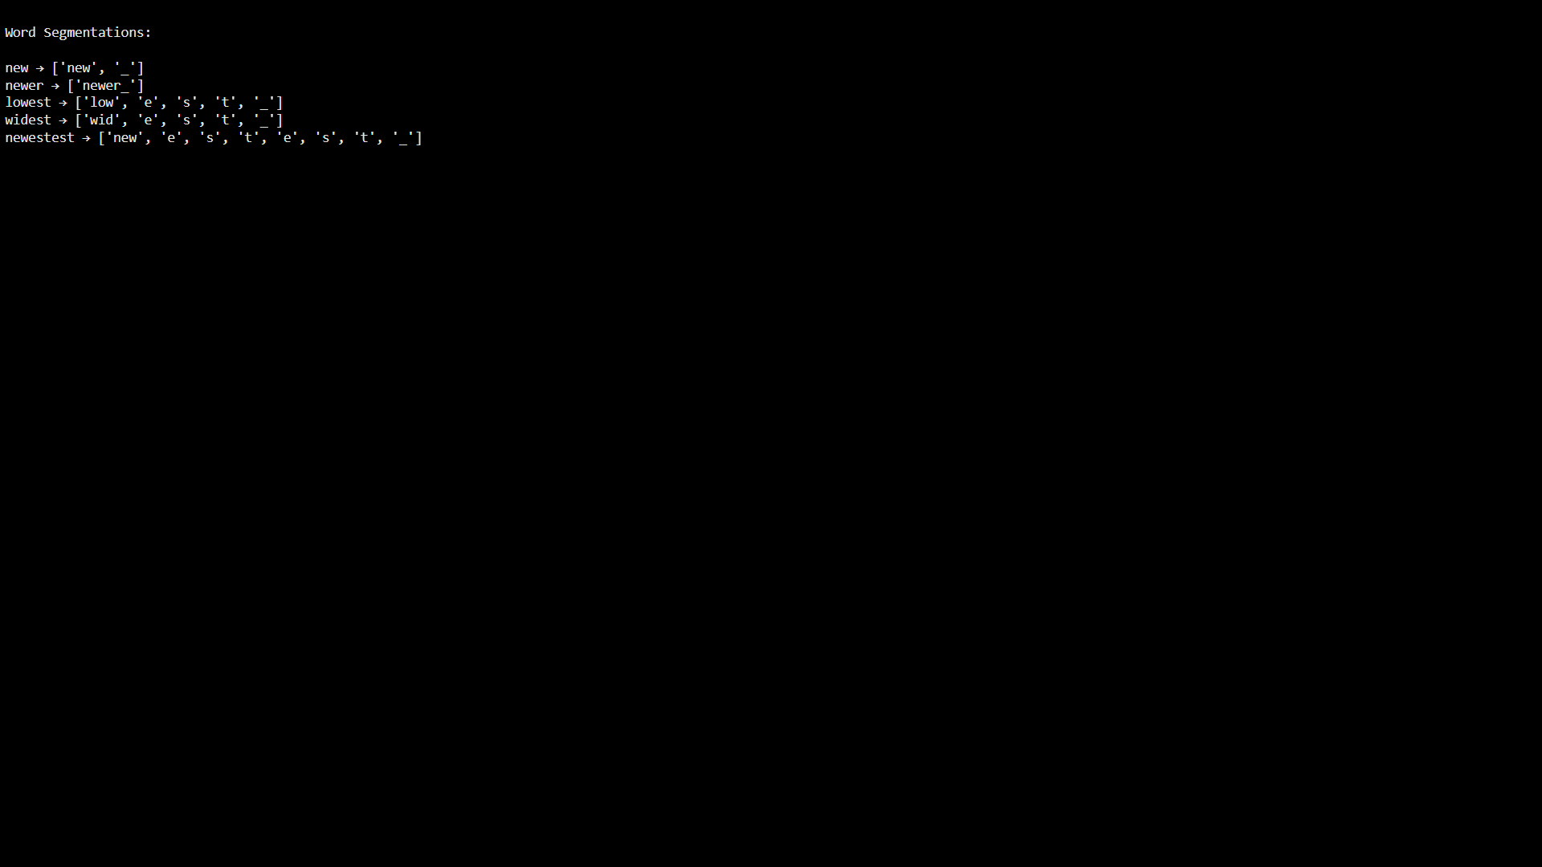

2.3 — Your language (or English if you prefer)
Pick one short paragraph (4–6 sentences) in your own language (or English if that’s simpler).
Natural language processing is an important area of artificial intelligence.
It helps computers understand human language.
Tokenization and subword modeling improve performance on rare words.
Learning meaningful representations is essential for modern NLP systems.
Subword methods reduce vocabulary size and handle unseen words.
- Train BPE on that paragraph (or a small file of your choice).
  - Use end-of-word _.
  - Learn at least 30 merges (adjust if the text is very small).
- Show the five most frequent merges and the resulting five longest subword tokens.
Code:
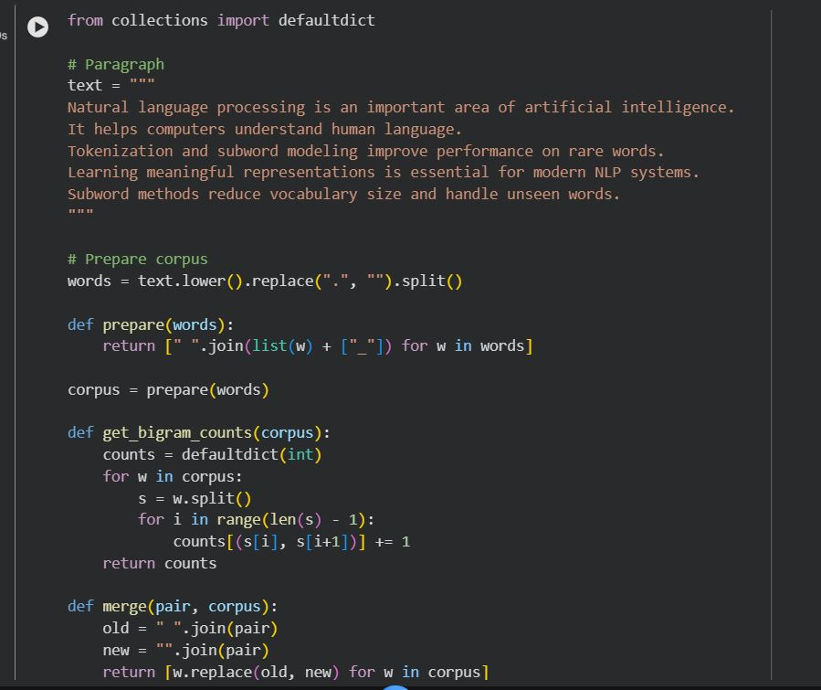
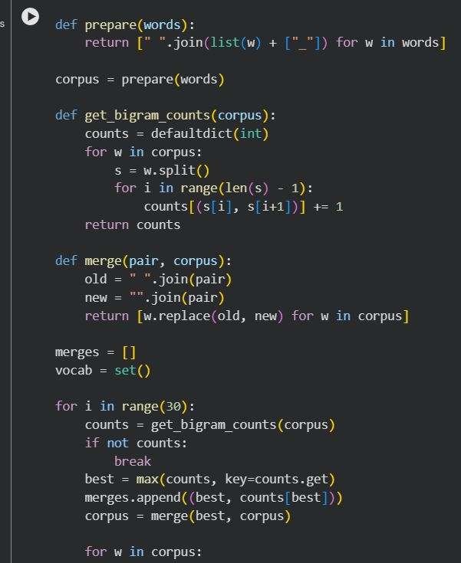
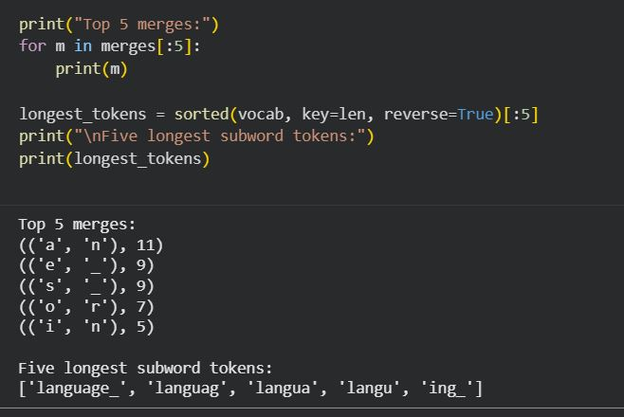
- Segment 5 different words from the paragraph:
  - Include one rare word and one derived/inflected form.
Code:
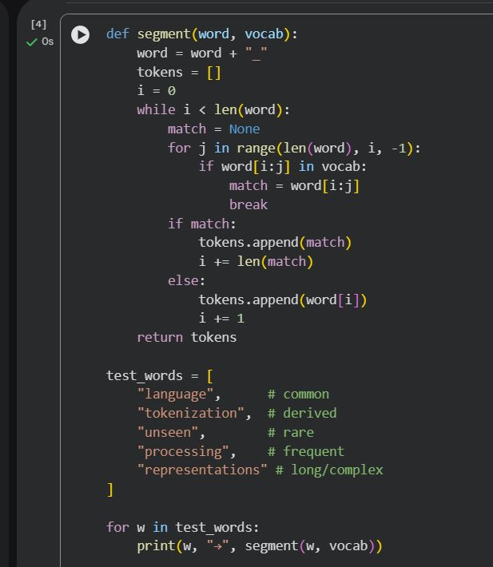
Output:
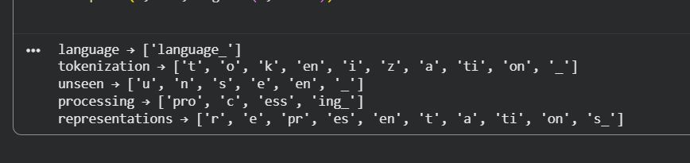
Programming Question:
1. Tokenize a paragraph
Take a short paragraph (3–4 sentences) in your language (e.g., from news, a story, or social media).
- Do naïve space-based tokenization.
- Manually correct the tokens by handling punctuation, suffixes, and clitics.
Submit both versions and highlight differences.
- Code:
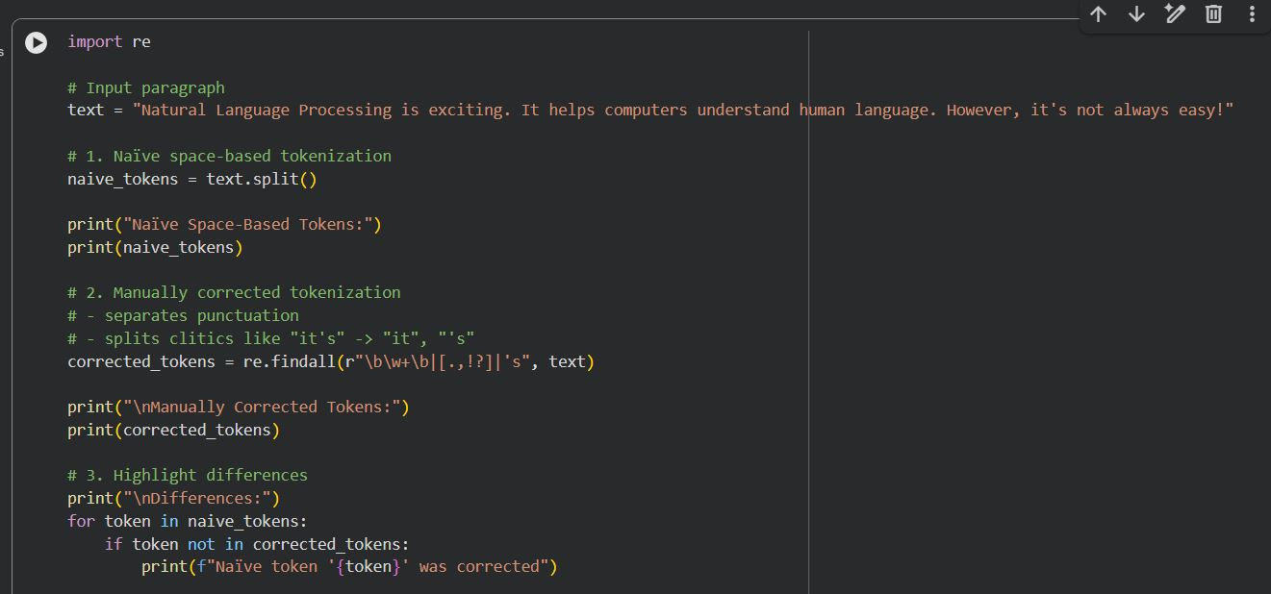
Output:
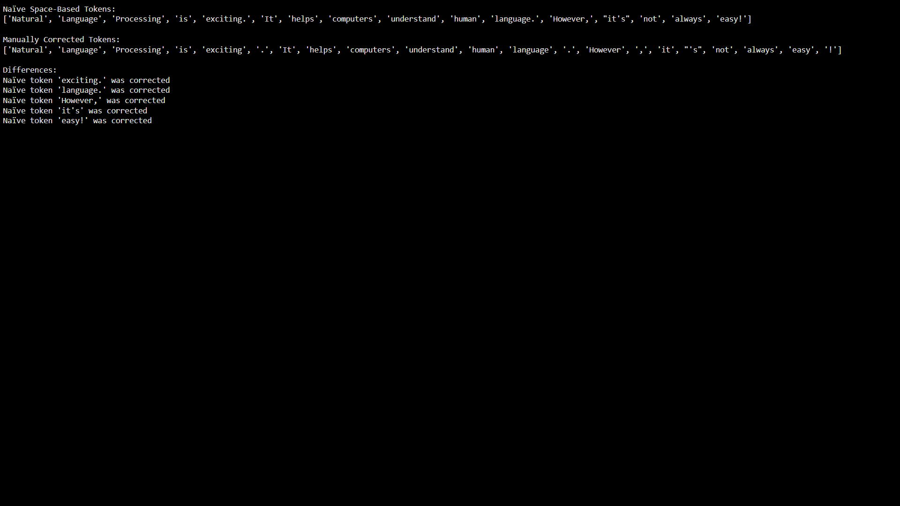
2. Compare with a Tool
Run the paragraph through an NLP tool that supports your language (e.g., NLTK, spaCy, or any open-source tokenizer if available).
- Compare tool output vs. your manual tokens.
- Code:
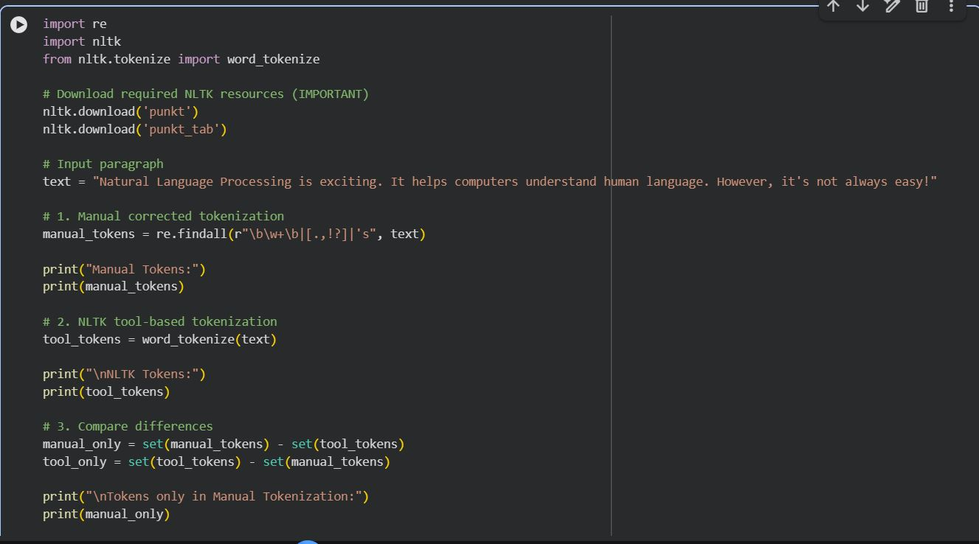
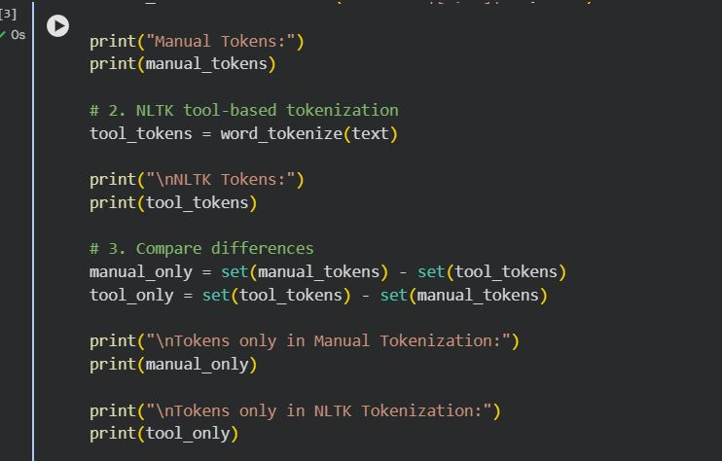
Output:
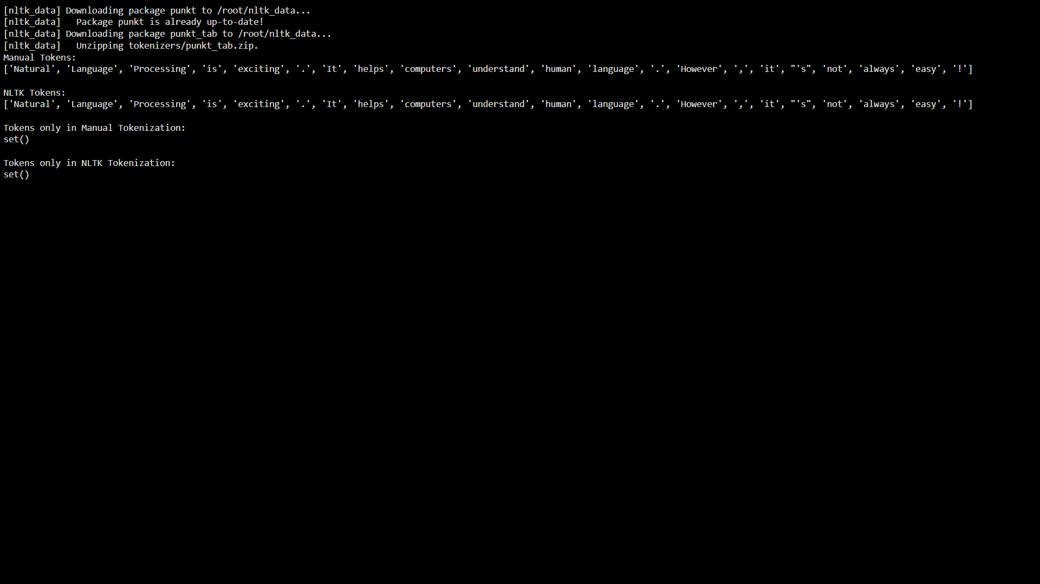
- Multiword Expressions (MWEs)
Identify at least 3 multiword expressions (MWEs) in your language. Example:
Code:
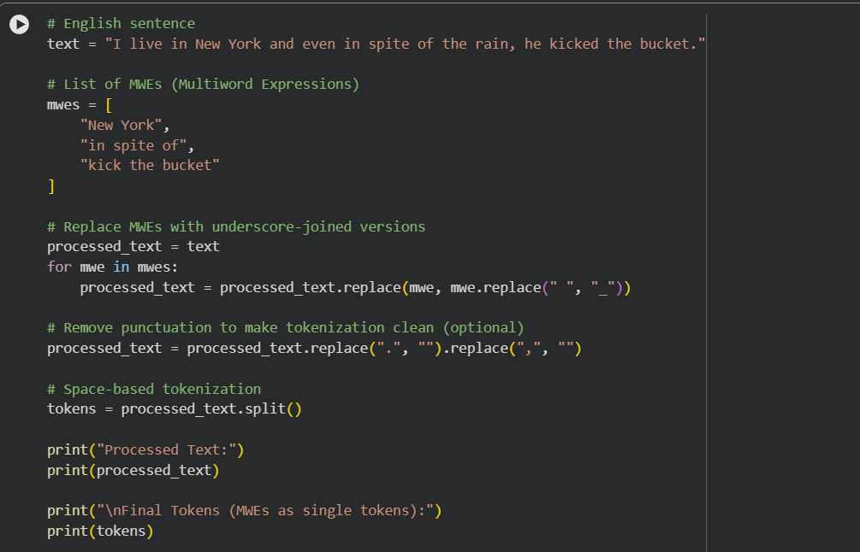
Output:
